

Estimated Time Saved from Manual Checking
 | {hours_saved}  total hours saved  from checking

Product Highlights 📌 | Top {top_n_teachers} Teachers 🎉
- {#product_highlights}{title}  {short_description}{/product_highlights} | - {#top_teachers}{teacher_name} ({department_name}){/top_teachers}

Total Utilization Percentage

Figure 1.1
{total_utilization_analysis}

Utilization by Department

Figure 1.2
{utilization_by_dept_analysis}

Assessments Checked & Estimated Time Saved
Assessment Type | No. of Assessments | Estimated Time Saved | Total Time Saved
Multiple  Choice | 162 | 216 hrs | {total_time_saved} hrs
Identification | 32 | 42.7 hrs
Enumeration | 12 | 8 hrs
Essay | 75 | 250 hrs
Problem Solving | 29 | 96.7 hrs
Code on Paper | 0 | 0 hrs
Visuals | 1 | 2 hrs
*Estimated Time Saved = (Average Manual Checking Minutes by Average No. of Items × Average No. of Students) × Number of Assessments. The result was converted to hours. Data for the time per item, and class size were gathered through teachers while data for the average items and number of assessments are gathered from GradeChum’s database.

Top GradeChum Users
Teacher Name |  | Department | Activities Created
{#top_teachers}{rank} | {teacher_name} | {department_name} | {activities_created}{/top_teachers}

Recommendations for Increasing Usage
To maximize GradeChum’s institutional impact, the following actions are recommended for implementation by college leadership:
Recommended Action (Dean) | Expected Outcome
- {#recommendations}{action} | - {outcome}{/recommendations}

Product Highlight Updates
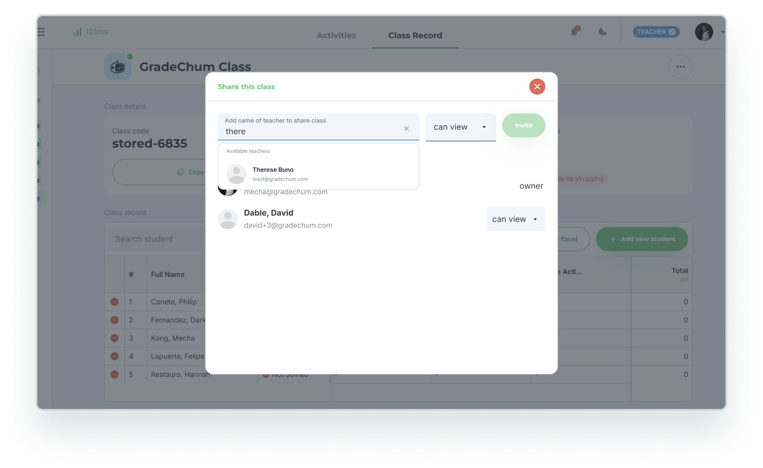
- Share Class to Co-Teachers
Teachers can now share their class with other teachers in their department, making collaboration easier and especially beneficial for departmental exams.

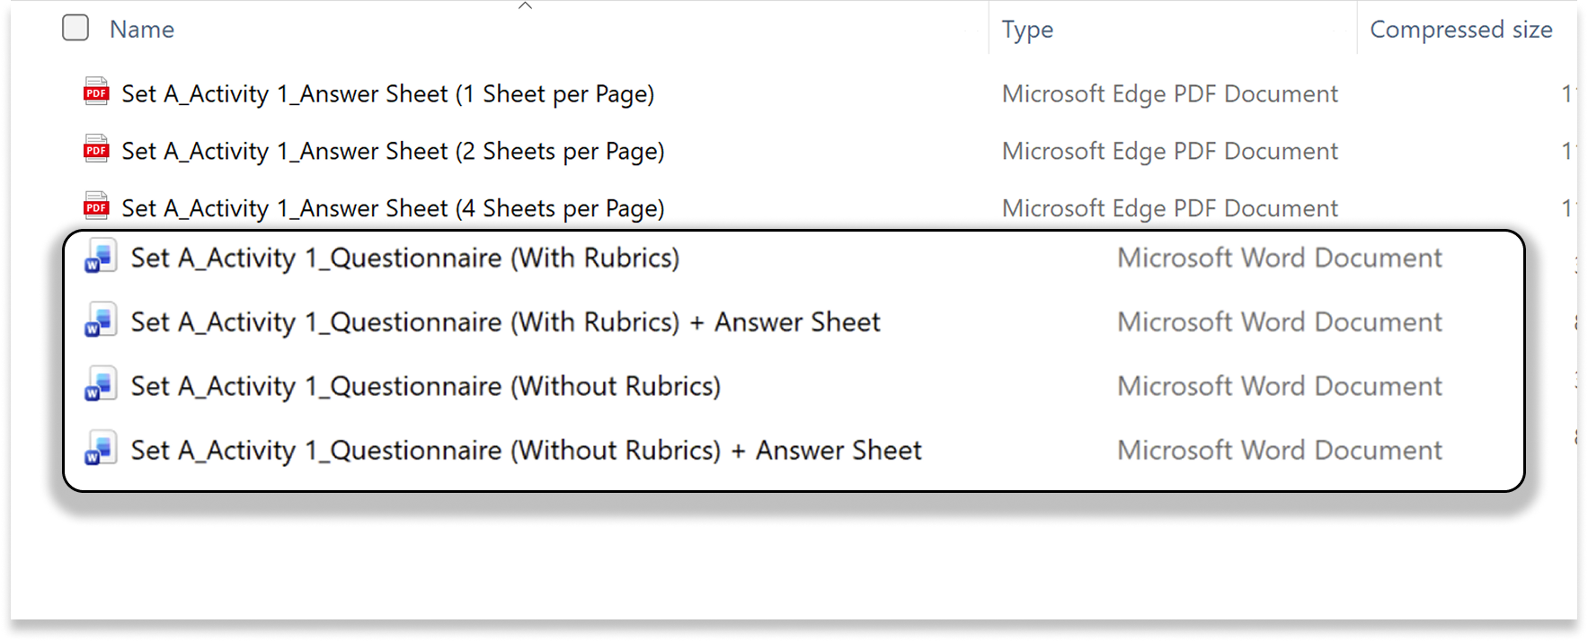
- Flexible Printing Options
You can now combine the questionnaire and answer sheet into a single paper, giving you more options and convenience in preparing assessments.

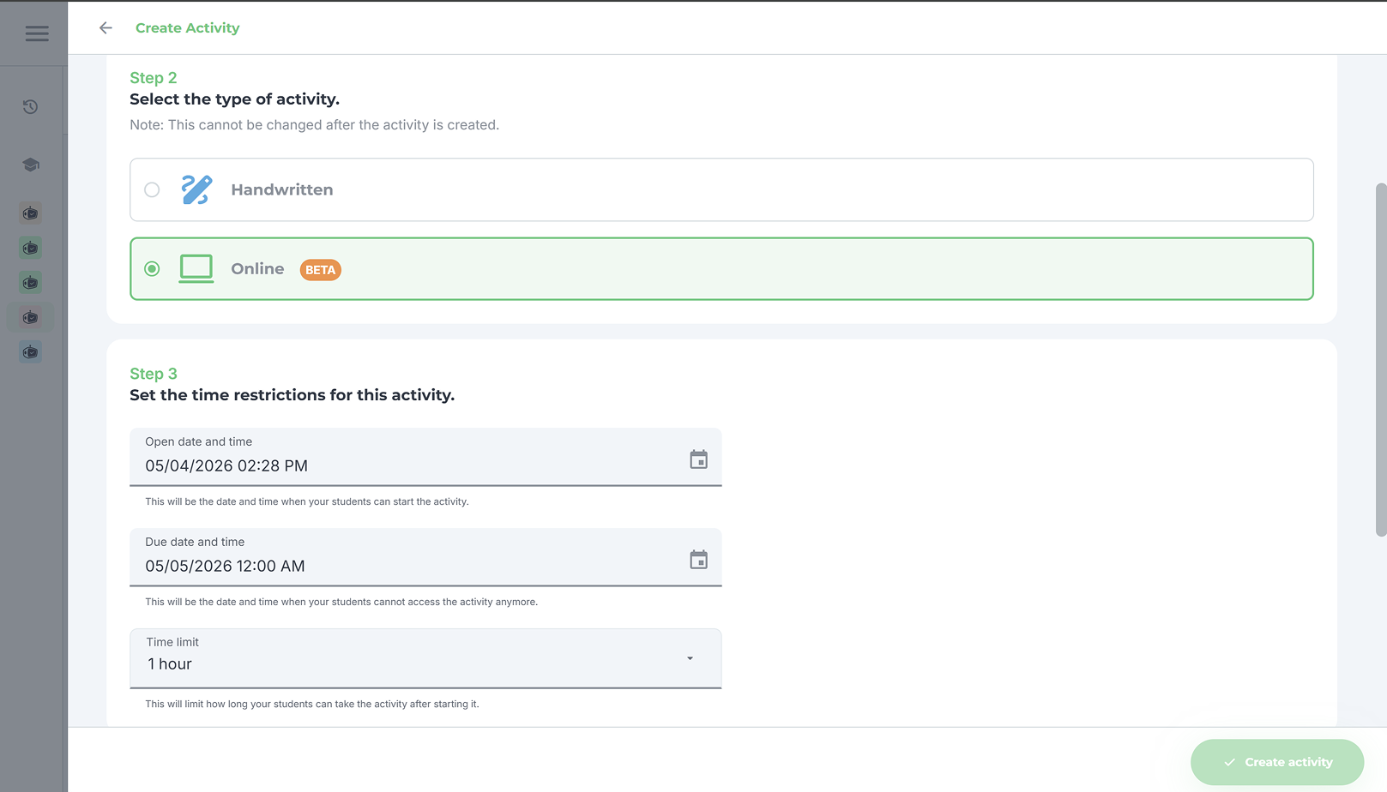
- Online Assessments
Teachers can now create and administer online tests directly in GradeChum, giving students a seamless way to take assessments anytime, anywhere.

- Mock Board Exam Class
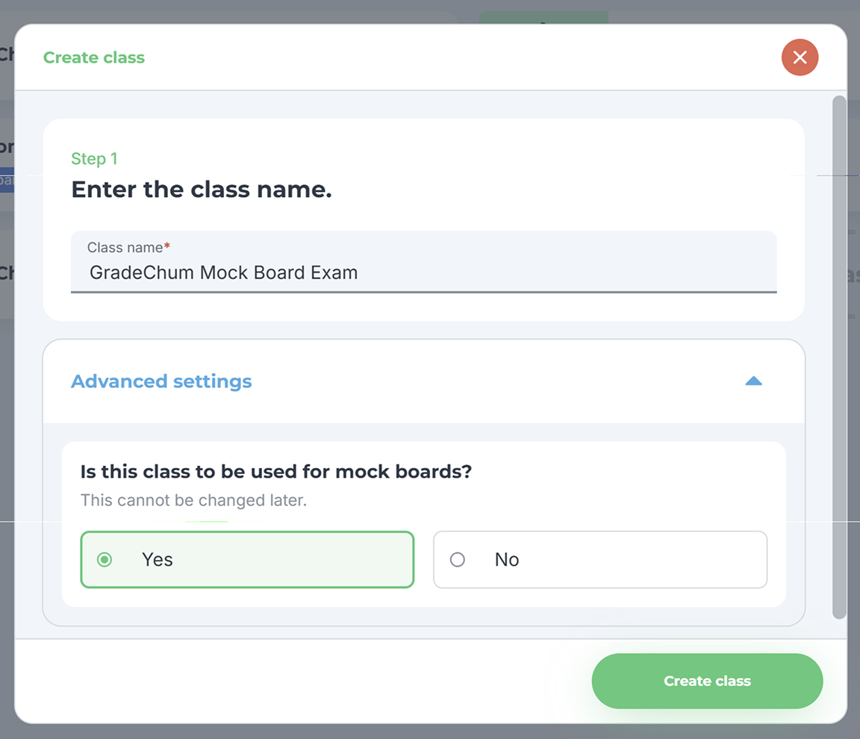
Teachers can create a single class that contains all subjects for the mock board exam, simulating real board exam conditions and giving students valuable practice to build confidence and readiness.

